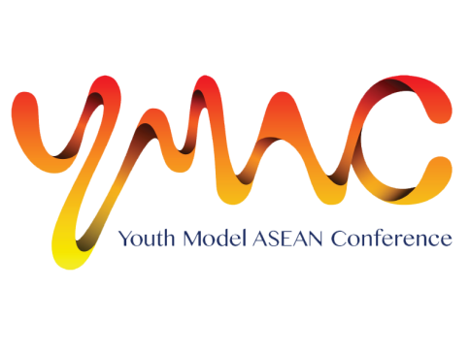
Affix Recent Photo
2014

Application Form
A: personal Particulars
Name (as in identity card/passport):

Gender: | Date of Birth: | Country of Birth:
Nationality: | Race: | Religion:
Home Tel: | Mobile phone no: | Email address:
Address:

Name of Institution: |  | Course of Study and Year:
Language(s) Written:

Language(s) Spoken:

Passport no:  *Please attach photo/scan of information page of passport. | Date of issue: | Date of expiry:  *Passport must be more than 6 months valid from date of travel (Dec 2014)
Dietary preference: Vegetarian / Halal / No preference

B: MEDIcal and Health Records
Blood type : ______

It is particularly important that any pulmonary, nervous or mental trouble, asthma related respiratory disorder, cardiovascular problem, previous prolonged ill-health, allergy, etc. should be stated.
Description of any drug allergy:

C: EMERGENCY CONTACTS
1st Emergency Contact Point:
Full Name :  (Please underline Surname) |  | Relationship:
Mobile: | Office: | Email:
Language(s) Spoken:

2nd Emergency Contact Point:
Name:  (Please underline Surname) |  | Relationship:
Mobile: | Office: | Email:
Language(s) Spoken:

D: Declaration
I declare that the above statements and those on the attached sheets are true to the best of my knowledge and belief, and that I have not willfully suppressed any material fact. I allow the organiser to use this information in anyway deemed necessary for the purpose of facilitating my application for the Conference.

____________________________
Signature of Applicant and Date

E: Parent’s/Guardian’s consent
I, _____________________________________________ , ____________________ give consent to the
(Name in Capital letters as in your identity document) (Identity document No)
participation of my child/ward* in the Youth Model ASEAN Conference (YMAC) 2014 held in Singapore from 18 to 23 December 2014 (includes travelling between home country and Singapore).

___________________________________
Signature of Parent/ Guardian* and Date

*delete accordingly

F: ESSAY
In about 300 words, describe one thing you would like to see changed or improved in your own country.

